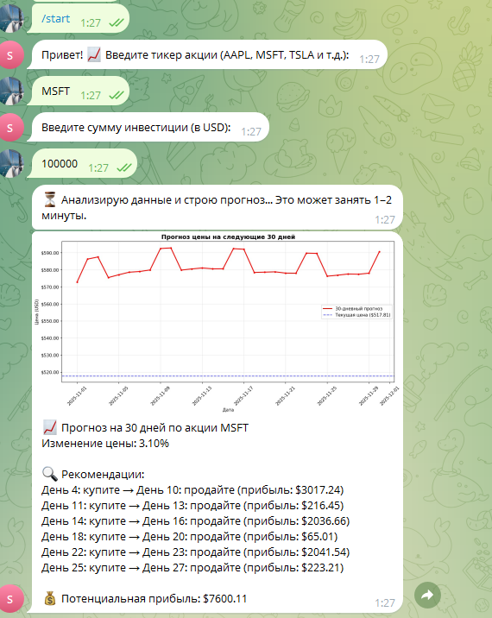

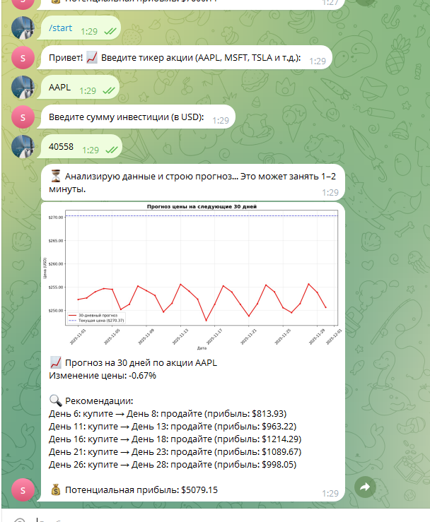
root@1cb9ddf57bd0:/app/logs# cat requests.log
user_id,datetime,ticker,amount,model,metric,metric_value,profit
363909238,2025-10-30T14:04:20.236172,AAPL,10000.0,Random Forest,MAPE,0.0157,774.54
363909238,2025-10-30T14:04:21.656749,AAPL,10000.0,Random Forest,MAPE,0.0157,774.54
363909238,2025-10-30T14:58:41.162368,AAPL,29000.0,Random Forest,MAPE,0.0157,2246.17
363909238,2025-10-30T14:58:42.258760,AAPL,29000.0,Random Forest,MAPE,0.0157,2246.17
363909238,2025-10-31T05:37:04.352930,MSFT,1000.0,Prophet,MAPE,0.0615,90.16
363909238,2025-10-31T05:37:05.600491,MSFT,1000.0,Prophet,MAPE,0.0615,90.16
363909238,2025-10-31T07:22:27.242627,AAPL,1000.0,Random Forest,MAPE,0.0161,89.49
363909238,2025-10-31T07:22:28.640625,AAPL,1000.0,Random Forest,MAPE,0.0161,89.49
363909238,2025-10-31T07:38:56.225118,MSFT,10000.0,Prophet,MAPE,0.06,864.02
363909238,2025-10-31T07:38:57.746491,MSFT,10000.0,Prophet,MAPE,0.06,864.02
363909238,2025-11-01T22:22:42.189536,AAPL,500.0,Random Forest,MAPE,0.0159,62.62
363909238,2025-11-01T22:25:05.253886,TSLA,45.0,Random Forest,MAPE,0.0309,9.34
363909238,2025-11-01T22:27:40.294696,MSFT,100000.0,Prophet,MAPE,0.0522,7600.11
363909238,2025-11-01T22:29:40.569712,AAPL,40558.0,Random Forest,MAPE,0.0159,5079.15

